ADVANCED C PROGRAMMING

LAB ASSIGNMENT-1

1)

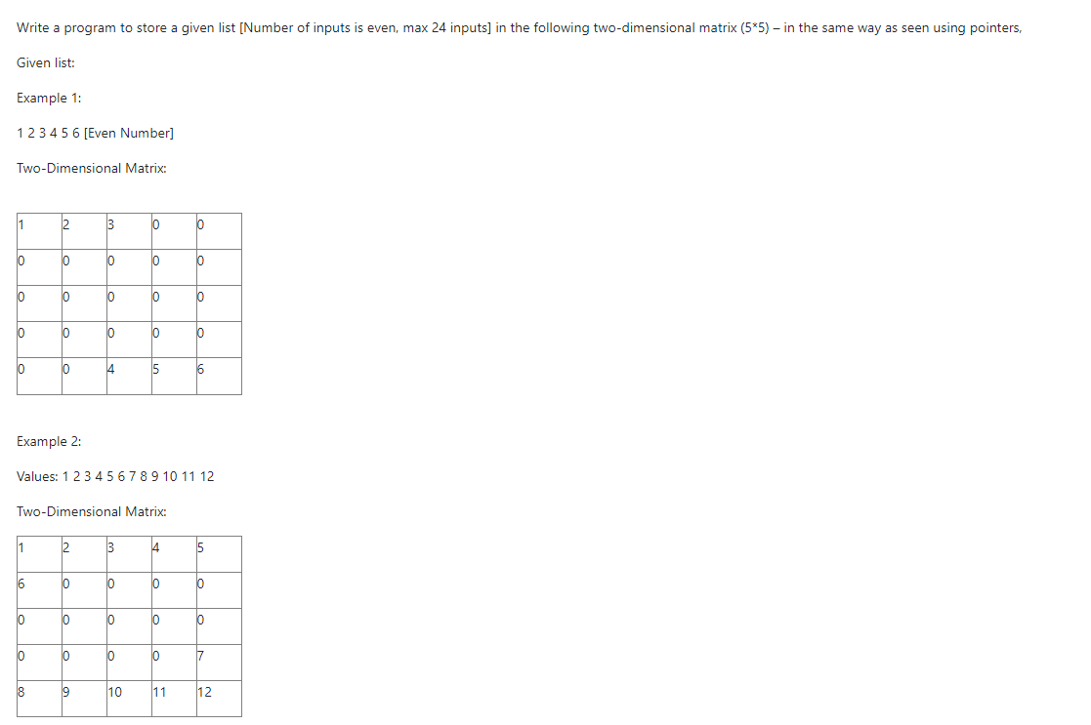

#include<stdio.h>

int main(){

int n,temp=0,pos=0;

scanf("%d",&n);

int arr[n];

int *p;

int half=n/2;

for(p=&arr[0];p<&arr[n];p++){

scanf("%d",p);

}

int res[5][5];

for(p=&res[0][0];p<&res[5][5];p++){

pos+=1;

if(pos<=half ){

*p=arr[temp];

temp+=1;

}

else if(pos>25-half){

*p=arr[temp];

temp+=1;

}

else{

*p=0;

}

}

for(int i=0;i<5;i++){

for(int j=0;j<5;j++){

printf("%d\t", res[i][j]);

}

printf("\n");

}

return 0;

}

2) Write a program to print the nearest integer value of corresponding float value given by the user, without using any library function.

#include<stdio.h>

int main()

{

float d;

scanf("%f",&d);

d=d+ 0.5;

printf("%d", (int)d);

return 0;

}

3) Try to print the following pattern using loops:

**0**

**1 0**

**0 1 0**

**1 0 1 0**

**0 1 0 1 0**

….

For n number of lines.

Eg. For n=1,

0

For n=3,

0

1 0

0 1 0

#include<stdio.h>

void pattern(int n){

int num=0;

for(int i=1;i<=n;i++){

if(i%2==0){

num=1;}

if(i%2==1){

num=0;}

for(int j=1;j<=i;j++){

if(num==0){

printf("%d\t",num);

num=1;

}

else if (num==1){

printf("%d\t",num);

num=0;

}

}

num=0;

printf("\n");

}

}

int main(){

int n;

scanf("%d",&n);

pattern(n);

}

4)

Write a program to print the output (sum) of the series, 1 + x + 2x + 3x... and 1 + x/2 + 2x/3 + 3x/4.. (Use double for output) till n numbers, where n is coefficient of x.

#include<stdio.h>

int main()

{

double n,sum,x=1;

sum=0;

printf("Enter n: ");

scanf("%lf",&n);

for(int i=1;i<n;i++){

sum+=(i);

}

printf("1 + %lfx\n",sum);

double sum2=0;

double j;

for(double i=1;i<n;i++){

j=(i/(i+1));

sum2+=j;

}

printf("1 + %lfx",sum2);

return 0;

}

5)

Write a program using function to indicate whether a given number is divisible by 5 or 6, if divisible by 5 multiply it to 6 or vice versa and return the value, indicate the divisibility also (which must be calculated in the function). In case the number is divisible by both then multiply the number by 10, then return it, and assign its divisibility as 6.

#include<stdio.h>

void divisibility(int num, int *nu5, int *nu6){

if(num%5==0){

*nu5=1;

}

if(num%6==0){

*nu6=1;

}

if(num%30==0){

*nu5=2,*nu6=2;

}

}

int main()

{

int num=30;

scanf("%d",&num);

int div5, div6;

divisibility(num,&div5,&div6);

if (div5==1){

printf("%d \t divisible by 5",num*6);

}

if (div6==1){

printf("%d \t divisible by 6",num*5);

}

if (div5==2 && div6==2){

printf("%d \t divisible by both 5 and 6",num*10);

}

return 1;

}

6)

Write a program to get four integer variables as input and do the check whether each of them is divisible by 2 and 3 or it is divisible by 5. If it is true and if more than one value is satisfying the condition then select the largest of the numbers which satisfy the condition and pass that value by reference to a function refer, multiply it by 10 and print the variable value in the main.

#include <stdio.h>

int divisible(int[], int);

int divisible(int arr[], int t)

{

int max = 0;

for (int i = 0; i < t; i++)

{

if (arr[i] > max)

{

max = arr[i];

}

}

return max*10;

}

int main()

{

int a[4];

int l[4] = {0, 0, 0, 0};

int t = 0, max=-5;

printf("Enter the values");

for (int i = 0; i < 4; i++)

{

scanf("%d", &a[i]);

}

for(int i=0;i<4;i++){

if (a[i] % 2 == 0 && a[i] % 3 == 0)

{

l[t] = a[i];

t++;

}

else if (a[i] % 5 == 0){

l[t] = a[i];

t++;

}

}

if (t > 1)

{

max = divisible(l, t);

}

else{

max=l[0];

}

printf("Maximum: %d\n", max);

return 0;

}

7)

Use only bitwise operators  and control statments for the following:

a. Check whether two numbers are equal

b. Check whether a number is odd or even

c. Check whether a number is positive or negative (note: the first bit is zero if it is positive)

#include<stdio.h>

int main(){

int a,b;

printf("Enter a: ");

scanf("%d",&a);

printf("Enter b: ");

scanf("%d",&b);

if(a&b==a){

printf("The numebers are equal");

}

else{

printf("Numbers not equal");

}

int num;

printf("\nEnter number to check for even/odd: ");

scanf("%d",&num);

if(num&1==1){

printf("Odd");

}

else{

printf("Even");

}

int num2;

printf("\n Enter number to check for pos/neg: ");

scanf("%d",&num2);

int sign=(num2>>31)&1;

if(sign==0){

printf("positive");

}

else if (sign==1){

printf("Negative");

}

return 0;

}

8)

Write a program to convert and display a decimal number in number with base 26, with its digit being represented as alphabets from a – z (0-25). Maximum size of input is 26*26 - 1. Eg. Inp = 25, out= az; inp = 26, out = ba; inp=52, out=ca.

#include<stdio.h>

#include<math.h>

int main(){

int n;

printf("Enter value in base 10: ");

scanf("%d",&n);

float index=n/26.0;

//printf("%f\n",index);

int firstplace=(int)index;

//printf("%d\n",firstplace);

char charone=(char)(97+firstplace);

printf("The value in base 26 is: ");

printf("%c",charone);

int secondplace= n -(26*firstplace);

//printf("%d",secondplace);

char secondchar=(char)(97+secondplace);

printf("%c",secondchar);

return 0;

}